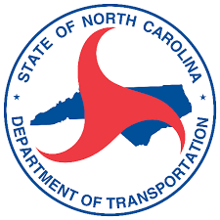

Anson County
Comprehensive Transportation Plan
August 18, 2022

- Introduction
- Socio-economic data
- Anson CTP Goals and Objectives Survey
  - Survey period and distribution
  - Survey walkthrough
- Integrated Mobility Division presentation
- Existing Anson County Pedestrian Facilities
- Bicycle and Pedestrian Crash locations
- Bicycle and Pedestrian Destinations
  - The importance of Bicycle and Pedestrian destinations
  - Identified destinations
  - Discuss additional destinations
- Future Meetings
- Wrap Up

